Aws 支持的输入源

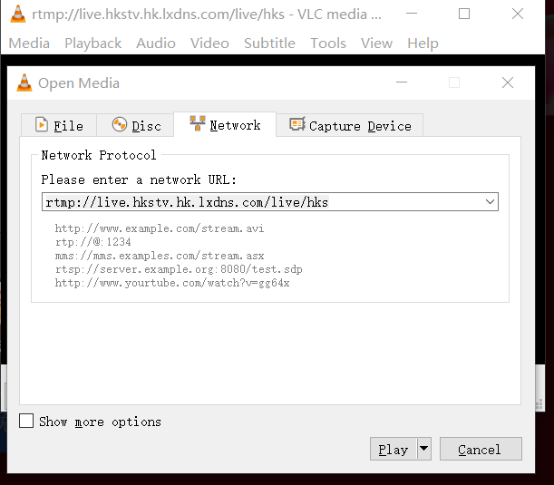

Input type – required

RTP

Push your source to fixed endpoints with the real-time transport protocol.

RTMP (push)

Push your source to fixed endpoints with the real-time messaging protocol.

RTMP (pull)

Pull your source from external endpoints with the real-time messaging protocol.

HLS

Pull your source from external endpoints with the HTTP protocol.

MP4

Ingest file content from an MP4 file that is on the public internet

TS

Ingest transport stream content from a TS file from external endpoints specified in the url.

MediaConnect

Ingest streaming content from one or two MediaConnect flows

AWS CDI

Push your uncompressed video over AWS Cloud Digital Interface.

Elemental Link

Ingest streaming content from an AWS Elemental Link device

先建立一个input

**Validation Errors**

**inputs[0].uri**

Invalid file extension ".m3u8" for input file uri, must use one of the following file extensions: .mp4,.ts,.m2ts

然后一个channel